Lesson Plan-Reading Informational Text
Lesson Links
- ELA Goals
- Specially Designed Instruction & Accommodations
- UDL Considerations
- Sample IEP Goal

Specially Designed Instruction-Reading Informational Text
Use this lesson with the website: Snapexplorer.com

- Set a Purpose
The purpose of this lesson is to
- Read to learn informational text.
- Find textual evidence to answer questions.
- Use the textual evidence to answer an inferential question.
- Use technology accommodations to help with the reading task.
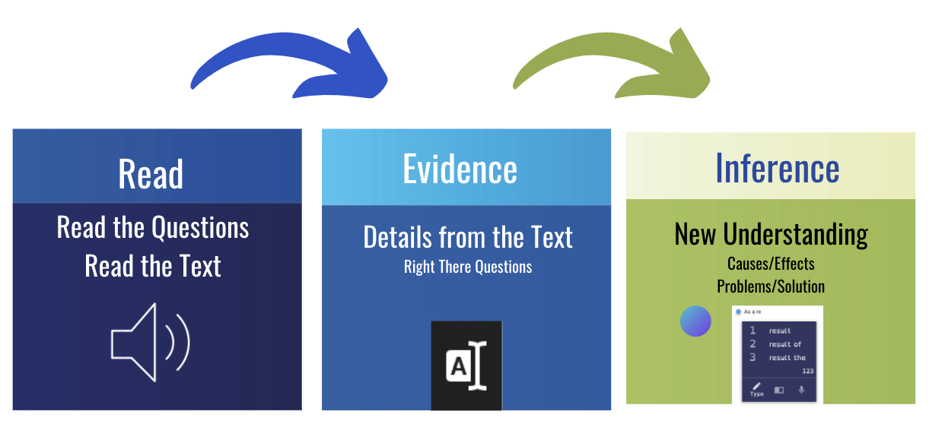
Teacher Task: I Do | Student Task
SAY: I am going to read to learn about informational text. First I am going to read and listen. Then I am going to look at the questions. I will re-read to find evidence. When I find evidence in the text. I will collect it in my note-taking window. The third question is an inference question. An inference is also known as an educated guess.  DO: Model the sequence described above | Watch what I am doing  Take notes  Ask questions
Teacher Task: We Do | Your Task
Modify what you did in the I DO by pausing/stopping and letting the student do part of it. You can say things like  “Now it is your turn to try.”  “What do you think we should do next”  “I will show you and then you can try it on your own” | Listen and watch the text read to you.  Pause the reader if you need to think about something  Reread the text - whole or part if you don't understand something  Ask yourself the question “what is evidence?”
Teacher Task: You Do | Your Task
Support and encourage your students as they work independently | Your task:  Read  Read and Listen to the Text  Evidence  Find the questions and highlight them which will move them to the note-taking window.  Find text evidence, highlight, add to eOrganizer  Inference Question (Question #3)  Using the text evidence you have gathered and what you know, write a sentence or a short paragraph to answer Question #3.
Turn in your work  Ask the student to finish and send you the document by email or uploading it to your classroom. | When done, go to the  “snowman” (3 dots)  Print or download and upload to your google drive.
Teacher Task: Next Steps
Reading: Repeat with other texts/assignments in general education classes.  Collaborative Learning-Repeat with another teacher/class. General Educator can deliver the I Do and We Do sections while the Special Educator/Therapist supports individual students.  Social Emotional/Behavior/Transition:  Discuss how the tools supported the students’ learning.  Discuss self-advocacy strategies for using Snap & Read other classes.  Transition goals: How will these tools be useful in your current classes and eventually your college classes or in a work setting. | You have assigned reading in many of your classes. Pick a class and a homework assignment where you need to read and answer questions. Using the strategies we practiced, try this in one of your classes.

ELA Standard Alignment
- Key Ideas & Details: Informational Text

Range of Reading Level and Text Complexity

Specially Designed Instruction & Accommodations
IEP-Determined Adaptations to Content | Research-Based Methodology | Delivery of Instruction
Modified text:  - Image Supported  - Simplified  - Questions easily accessible  Readaloud  Assistive Technology: Text-to-speech  eHighlighter and eOrganizer to organize questions and textual evidence and cite evidence  Word Prediction with Topic Dictionary to support Writing notes for inference | Gradual Release Model  https://www.readingrockets.org/blogs/shanahan-literacy/gradual-release-responsibility-and-complex-text  I Do - Direct Instruction  We Do - Guided Instruction  You Do - Independent Practice | eLearning  Face to Face  Small Group  Pre-teaching

Sample IEP Goals:

Reading: Sample Standards-based ELA reading goal:
Given digital text and a text reader with citation tools, by (date) student will cite a minimum of 3 pieces of textual evidence from an informational text at their independent reading level and explain how the evidence supports the claim scoring 75% or higher on a teacher rubric.

Social Emotional/Behavior Goal
Self-Advocacy: Given Assistive Technology & Accommodations, student will identify and advocate use of tools and strategies as evidenced by 4 outline/notes turned in as assignments.

Transition Goal
Given direct instruction and guided practice using assistive technology for reading assignments, student will use 1-4 different tools independently in 4 different reading assignments.

UDL Considerations
Multiple Means of Representation | Multiple Means of  Action and Expression | Multiple Means of Engagement
AUDITORY  - Text with text reader  - Video with closed captioning  LANGUAGE/Vocabulary  - Dynamic text leveling Double-click dictionary (turn on in options)  - Translate text (turn on in options)  - Additional text at different readability levels  VISUAL  - Color overlay extra contrast  - Printed versions with various fonts  - Increase size of window  - Change contrast in accessibility settings.  - Additional Pictures and picture walks  Snap&Read | Writing Responses:  Inference Questions  - Word Prediction  - Speech to Text (Voice Dictation)  - Translation support  Highlighting tools  Outlines  Graduated levels of support  ( additional I do and We do or other evidence-based strategy such as QAR)  Student generates questions  (use evidence-based KWL strategy )  Novel responses  Goal setting  Use PDF version and use Annotations  High tech or no tech options  Co:Writer and Snap&Read | High interest topics  Relevance to general education curriculum  Accessible text and format  Increase mastery with support and feedback  Facilitate independence through scaffolding and repeated practice with accessible text and formats  Promote problem solving/ embedded help functions  Minimal distractions with simplified interface/easy navigation  Attention-give breaks after each section

