Lesson Plan-Vocabulary Acquisition and Use
Lesson Links
- ELA Goals
- Specially Designed Instruction & Accommodations
- UDL Considerations
- Sample IEP Goal

Specially Designed Instruction: Vocabulary Acquisition and Use
Use this lesson with the website: Snapexplorer.com

- Set a Purpose
The purpose of this lesson is to;
- Learn new vocabulary words in informational text
- Look for hints and cues about word meaning
- Define words with expert definitions
- Actively process new vocabulary with an organizer
- Use vocabulary in writing
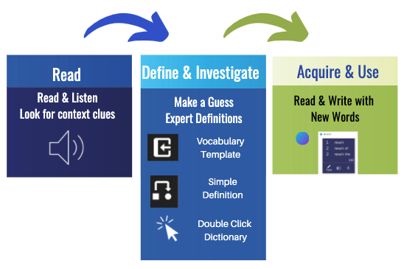
Teacher Task: I Do | Student Task
SAY: The purpose of today’s lesson is to learn new words  Read  We are going to read or listen to the text and identify words we don’t know. When we don’t know a word, we are going to use clues & strategies to try and figure it out.  Define  We will read/listen to the definition by clicking on the word.  Acquire and Use  We will use strategies to help us remember the word.  We will also try and use the word in a new sentence.  DO: Model the sequence described above | Listen to the text  Read  Let me know when you read/hear new words you did not know before  Say “new word” when you hear a new/unfamiliar word  Define  Make a guess about the word using clues from the text  Watch how to use technology to learn about the word  Acquire and Use  Listen to facts and ideas that go with the word and ones that do not  Listen to how the new word can be used in a sentence
Teacher Task: We Do | Student Task
Modify what you did in the I DO by pausing/stopping and letting the student do part of it.  You can say…  “Now it is your turn to try.”  “How can this vocabulary organizer break this down into smaller pieces”  “What are words you don’t know”  “What do you think we should do next”  “I will show you and then you can try it on your own”  “Which steps should we do together and which steps can you try on your own?” | Read  Listen and watch the text read to you  Pause the reader when you find a word you don’t know  Define  Make a guess using clues (word parts, how it sounds in the sentence or paragraph)  Double click on the word to hear the definition  Acquire and Use  Think of facts and ideas that go with the word and ones that do not  Brainstorm how the word can be used in a sentence
Teacher Task: You Do | Student Task
Support and encourage your students as they work independently | Read  Read and Listen to the Text  Look for hints and cues about word meaning  Define  Find vocabulary, highlight, add to eOrganizer  Acquire and Use  Write a sentence with the new word
Turn in your work  Ask the student to finish and send you the document by email or uploading it to your classroom. | When done, go to the  “snowman” (3 dots)  Print or download and upload to your google drive.
Teacher Task: Next Steps | Student Task
Reading: Repeat with other vocabulary assignments in general education classes.  Build Background Knowledge: Repeat with upcoming reading assignments-study vocabulary before the class lesson.  Collaborative Learning-Repeat with another teacher/class.  General Educator can deliver the I Do and We Do sections while the Special Educator/Therapist supports individual students.  Social Emotional/Behavior/Transition:  Discuss how the tools supported the students’ learning.  Discuss self-advocacy strategies for using Snap & Read other classes.  Transition goals: How will these tools be useful in your current classes and eventually your college classes or in a work setting. | You have assigned reading in many of your classes. Use the strategies we practiced to define and remember new words.

ELA Standard Alignment
- Vocabulary Acquisition and Use

Knowledge of Language

Specially Designed Instruction & Accommodations
IEP-Determined Adaptations to Content | Research-Based Methodology | Delivery of Instruction
Modified text:  - Essential vocabulary identified  - Image Supported text  - Graphic dictionary  - Simplified text  - Contextual support  Readaloud  Assistive Technology: Text-to-speech  eHighlighter and  eOrganizer/Graphic Organizer for structured vocabulary study  Word Prediction with Topic Dictionary to utilize new vocabulary in writing repeatedly | - High interest text  - Explicit instruction  - Graphic support  - Gradual Release Model  1. Set a purpose  2. Focused lesson (I do)  3. Guided practice (We do)  4. Independent practice (You do) | - Explicit instruction  - Pre-teaching  - Modeling  - Repeated opportunities for practice  - eLearning  - Face to Face  - Small Group

Sample IEP Goals:

Sample Standards-based ELA Goal:

Given an informational text, student will determine or clarify the meaning of teacher selected/ unknown and words by using context clues, analyzing word parts, and consulting reference materials as demonstrated by completing an outline or graphic organizer with 80%accuracy.

Social Emotional/Behavior Goal:
Self-Advocacy: Given Assistive Technology & Accommodations, student will identify and advocate use of tools and strategies as evidenced by 4 outline/notes turned in as assignments.

Transition Goal:
Given direct instruction and guided practice using assistive technology for reading assignments, student will use 1-4 different tools independently in 4 different reading assignments.

Speech & Language Goal (Vocabulary)
Given words, student will be able to define age-appropriate vocabulary words using context clues, expert definitions, synonyms, antonyms, and by example during structured activities with 80% accuracy and minimal cues.

Occupational Therapy Goal (Executive Functioning, Working Memory, Graphic Organizer)
The student will use graphic organizers to record or recall content knowledge as evidenced 8 outlines turned in as assignments.

UDL Considerations
Multiple Means of Representation | Multiple Means of  Action and Expression | Multiple Means of Engagement
AUDITORY  - Text with text reader  - Video with closed captioning  LANGUAGE/Vocabulary  - Dynamic text leveling Double-click dictionary (turn on in options)  - Translate text (turn on in options)  - Additional text at different readability levels  VISUAL  - Color overlay extra contrast  - Printed versions with various fonts  - Increase size of window  - Change contrast in accessibility settings.  - Additional Pictures and picture walks  Snap&Read | Writing Responses:  - E-organizer: Choice of Vocabulary Organizers  - Word Prediction  - Speech to Text (Voice Dictation)  - Translation support  Highlighting tools  Graphic Organizer Choice for Vocabulary Study  Graduated levels of support  (additional I do and We do or other evidence-based strategy such as Frayer model)  Student generates sentences with new vocabulary  Novel responses  Goal setting  Use PDF version and use Annotations  High tech or no tech options  Co:Writer and Snap&Read | High interest topics  Relevance to general education curriculum  Accessible text and format  Increase mastery with support and feedback  Facilitate independence through scaffolding and repeated practice with accessible text and formats  Promote problem solving/ embedded help functions  Minimal distractions with simplified interface/easy navigation  Attention-give breaks after each section

